

**User Interface Specification**

**Document**

**16.04.2021**

**Elif Ünlü**

**Contents**

**1. INTRODUCTION**

1.1 Purpose of document 3

1.2 References 3

1.3 Overview 3

**2. Parts of User Interface**

2.1 Top bar 4

2.2 User ınformation entry 4

2.3 Lıst of Users 4

1. **Introduction**
   1. **Purpose of Document**

Purpose of this user interface specification document is giving information about the requirements, details related to UI components, the behavior of the page when using these components.

* 1. **References**

<https://www.cisco.com/c/en/us/td/docs/solutions/Enterprise/collaboration/Remote_Expert/REM_1-9/Release_1_9_6/AdminGuide/RemoteExpert_AdminGuide/196_Ch2_UIdesign_0917.pdf>

<http://www.egnos-pro.esa.int/Publications/SISNET/sisnet_uid_2_0.pdf>

<https://ec.europa.eu/transport/sites/transport/files/facts-fundings/tenders/doc/specifications/2015/s152-279497-appendixa-enclosure2.pdf>

* 1. **Overview**

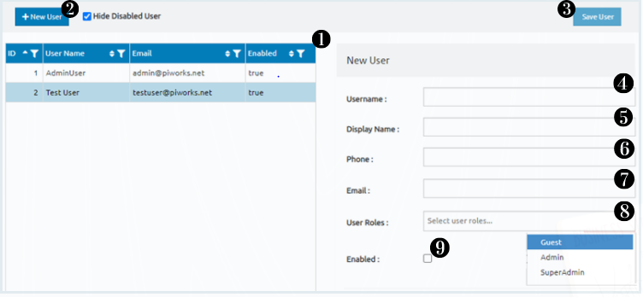

Figure 1

In Figure 1, you can see all parts of user interfaces. This interface is used to save user to system and to see users that is saved by user. The parts of the interface are numbered as you can see in Figure 1. We can list the names of the numbered parts as follows:

1. Table of users
2. Button of “New User”
3. Button of “Save User”
4. Entry of “Username”
5. Entry of “Display Name”
6. Entry of “Phone”
7. Entry of “Email”
8. Dropdown list of “User Role”
9. Checkbox of “Enabled”
10. **Parts of User Interface**
    1. **Top Bar**



Figure 2

**Purpose :** This bar is used for enabling users to access “New User” and “Save User” buttons.

**Navigation & User Interaction:** If the user click “New User” button, he/she can create new user which have no attribute. Moreover, ıf the user click “Save User” button, he/she can save user whose information is logged in to the system and he/she can see in the list of user, see Figure 1 no 1.

* 1. **User Information Entry**

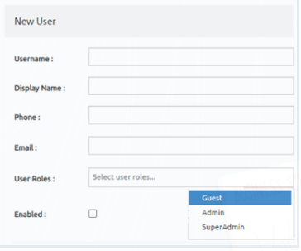

Figure 3

**Purpose :** This part is the part where the properties of the user that will be saved in the system are entered. It includes 5 entries and 1 checkbox, see Figure 1 or Figure 3.

**Navigation & User Interaction:** The user must enter information that are “Username”, “Display Name”, “Phone”, and “Email” manually. However, in the dropdown list, the user must select must choose one of the options registered in the system as “User Role”. These options are “Guest”, “Admin”, “SuperAdmin”. In addition, the user can mark “Enabled” option as true or false.

* 1. **List of User**

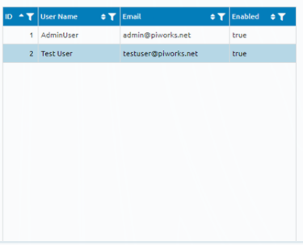

Figure 4

**Purpose :** This list is used for enabling users to view users that saved in the system.

**Navigation & User Interaction:** The list shows users information. These information are ID, User Name, Email, and status of enabled. Furthermore, these information can be filtered.